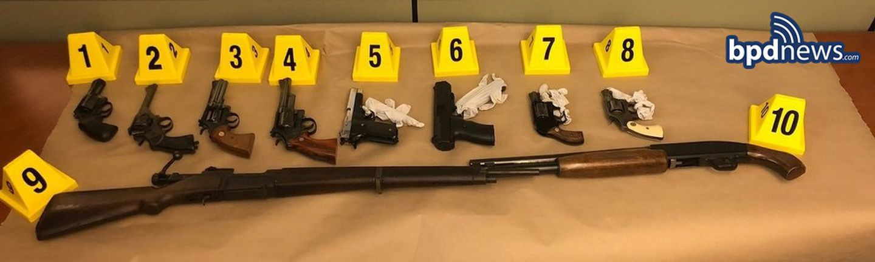



**Man accused of shooting in**

**Roxbury held for mental evaluation**

**By Jerome Campbell** Globe Staff, September 25, 2018, 8:45 p.m.

**3**

The weapons Boston police say were taken from the home of suspect Ismail Abdurrashid. BOSTON POLICE



A Roxbury man who shot a member of his mosque and was found in possession of 10 firearms was ordered held Tuesday at a state hospital for mental evaluation.

Police said that Ismail Abdurrashid, 50, went to the Mosque for the Praising of Allah in Roxbury early Monday morning and shot a man twice. The man, who is in his mid-50s, is expected to survive.

The man told police Abdurrashid targeted him because he didn’t like how the mosque was being run, according to a police report. Abdurrashid was also angry because he believed the man was a sex offender, police said.

Advertisement

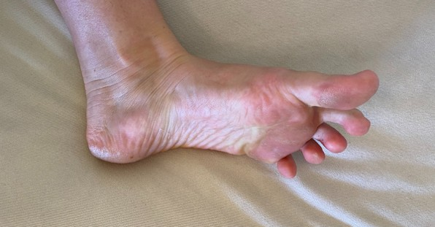

**4 Signs Your Heart Is Quietly Failing You**

Sponsored by PhysioTru

At his arraignment in Roxbury District Court, Abdurrashid pleaded not guilty to two dozen charges, including assault to murder. A court clinician told the court that Abdurrashid had been released from Massachusetts General Hospital’s psychiatric service three days ago.

His family and friends had seen a severe change in Abdurrashid’s behavior in the past month and said he needed help, she said.

**BOSTON GLOBE VIDEO**

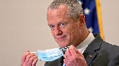

2:23

Baker announces ‘VaxM SHARE

Get Today's Headlines in your inbox

[example@email.com](mailto:example@email.com)

**Sign Up**

The day's top stories delivered every morning.

Enter Email

Governor Charlie Baker announced residents who are fully vaccinated against COVID-19 will have the chance to win $1 million in a special Lottery sweepstakes. (Photo by Matt Stone/Boston Herald via AP)

“There has been a significant change to his mental status over the last month and it has been dramatic,” said Sandra Ehlinger, the court clinician. “Virtually anyone who knows him has reported that it is very much out of character and very much is in need of some sort of psychiatric care.”

**s ns’**

**rd**

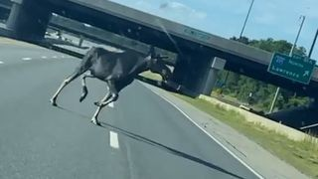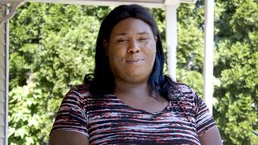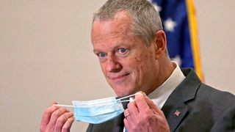

**Baker Moose What announce spotted Black ‘VaxMillio on liberation lottery Route 3 means program in to me:**

**Chelmsfo Athena**

**Vaughn**

**NOW PLAYING**

Speaking on his own behalf, Abdurrashid said he was “more than competent to answer to these allegations.”

“I am not crazy,” he said. “I am sane and I will answer to any and all charges in the court of law.”

Police said that Abdurrashid arrived at the mosque around 6 a.m. and knocked on a door. When the victim opened it, Abdurrashid began shouting and a fight broke out. At some point during the struggle, Abdurrashid drew a gun and fired twice, striking the man in the leg and shoulder, police said.

The man then chased Abdurrashid out of the building, a witness told police.

Advertisement

An imam at the mosque helped the two men identify Abdurrashid, police said. Another mosque member told police he spoke with Abdurrashid that morning near the mosque and Abdurrashid said he was going to shoot the victim.

Later on Monday, officers found Abdurrashid on Townsend Street near his home and arrested him. In a search of his home, they seized 10 firearms, including a sawed-off shotgun and eight handguns.

**MOST POPULAR ON BOSTONGLOBE.COM**

1. Life sciences is poised to be Boston’s dominant industry. Has the area become the Silicon Valley of biotech?
2. Baker announces ‘VaxMillions’ lottery program, offering $1 million cash prizes to boost vaccination rates
3. How Massachusetts communities are celebrating the state’s first official Juneteenth
4. Too hot? Sky-high prices may be scaring some buyers away from the housing market
5. Message in a bottle, tossed into the sea in Rhode Island, found in Azores
6. A treasure map for an American tyrant
7. Death penalty should be reinstated for Tsarnaev in Boston Marathon bombings case, Biden administration tells Supreme Court
8. ‘It was an ugly win.’ Nothing came easy in Red Sox’ victory over Braves
9. I got the Johnson & Johnson vaccine. The pause makes me believe in it more.
10. America's blind spot: Thousands of drivers shouldn't be licensed

Abdurrashid is scheduled to return to court on Oct. 15.

[Jerome Campbell can be reached at jerome.campbell@globe.com or](mailto:JeromeCampbellcanbereachedatjerome.campbell@globe.comor) @jeromercampbell

**Show comments**



**VIEWS FROM OUR COLUMNISTS**

**YVONNE ABRAHAM**

Energy efficiency is a low- hanging fruit to combat climate change. So why can’t everyone get access to it?

**KEVIN CULLEN**

Bill Bratton on American policing and the challenge facing the Boston Police Department

**THOMAS FARRAGHER**

A salute across the ages to an old squad leader

**SHIRLEY LEUNG**

A working mother’s manifesto: Pandemic provides a once-in-a- generation chance to course correct how we work

**JENEÉ OSTERHELDT**

Juneteenth and the meaning of Black liberation in Boston

**ADRIAN WALKER**

‘The best Boston movie no one’s ever seen’: ‘Blue Hill Avenue’ at 20

**MORE ON GLOBE.COM**

**SPONSORED BY: PHILIP MORRIS INTERNATIONAL**

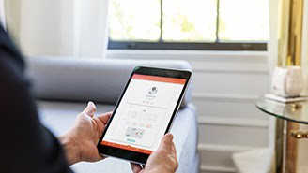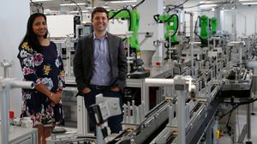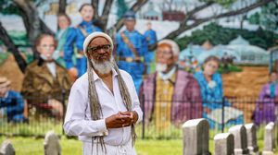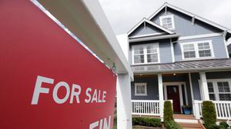

**Remote health care could be — and should be — here to stay**

In response to the pandemic, insurers expanded coverage for virtual health services. How long will it last?

**INNOVATION ECONOMY**

**Life sciences is poised to be Boston’s dominant industry. Has the area become the Silicon Valley of biotech?**

Since December, you can find six major indications that Boston is the undisputed center of the life sciences industry, a place where ideas and products that change — and save — people’s lives around the world originate.

**How Massachusetts communities are celebrating the state’s first official Juneteenth** For more than a century, Juneteenth was a Texan holiday, then a Southern holiday, commemorating the anniversary of June 19, 1865, when General Gordon Granger of the Union Army told formerly enslaved people in Galveston they were free. Now it will be celebrated for the first time across the Commonwealth as an official state holiday.

**Too hot? Sky-high prices may be scaring some buyers away from the housing market**

A real estate trade group said Wednesday that there are some signs that the blistering seller’s market may be softening modestly after months of rising values.

**RED SOX 10, BRAVES 8**

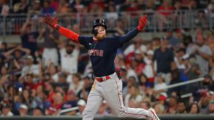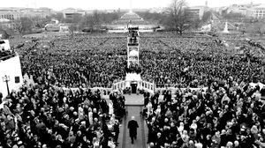

**‘It was an ugly win.’ Nothing came easy in Red Sox’ victory over Braves**

Alex Verdugo homered to lift the Red Sox on Tuesday in a game that included pitching mishaps, a slugfest, and some sloppy defense.

**A treasure map for an American tyrant**

Donald Trump exposed weaknesses that a would-be dictator could exploit to end our democracy. It’s now up to lawmakers, voters, and public officials to prevent that from happening.

**RI NEWS**

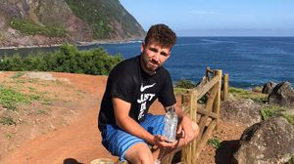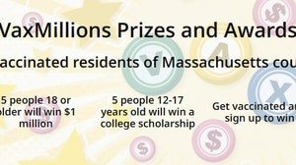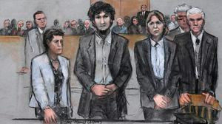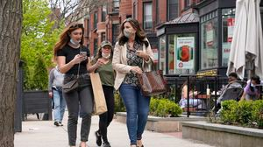

**Message in a bottle, tossed into the sea in Rhode Island, found in Azores**

The note was written in 2018 by a 13- year-old who was visiting family in Rhode Island.

**Baker announces ‘VaxMillions’ lottery program, offering $1 million cash prizes to boost vaccination rates**

State officials on Tuesday said residents who are fully vaccinated against COVID-19 will have the chance to win $1 million in a special Lottery sweepstakes.

**Death penalty should be reinstated for Tsarnaev in Boston Marathon bombings case, Biden administration tells Supreme Court**

The Biden administration is asking the Supreme Court to reinstate the death penalty against Dzhokhar Tsarnaev for the Boston Marathon terror bombings.

**The downside of ditching masks: the return of colds, flu** Since the state’s mask mandate was lifted, face coverings have started to come off — and stay off. But according to infectious diseases doctors, the return of facial freedom might come with some downsides, like a resurgence in cases of the common cold and the flu.

**METRO SPORTS BUSINESS & TECH OPINION**

WELCOME, JOHN

**TODAY'S PAPER**

**Check out this week's**

**virtual events**

RSVP now

**MOST READ IN THIS SECTION**

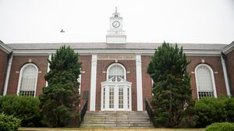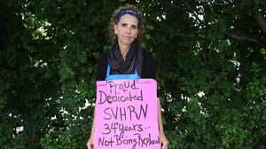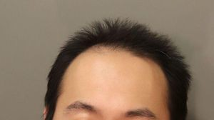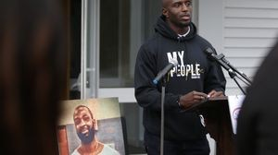

**How Massachusetts communities are celebrating the state’s first official Juneteenth**

**RI NEWS**

**Message in a bottle, tossed into the sea in Rhode Island, found in Azores**

**America's blind spot: Thousands of drivers shouldn't be licensed**

**Death penalty should be reinstated for Tsarnaev in Boston Marathon bombings case, Biden administration tells Supreme Court**

**UMass Lowell to remain closed Wednesday while investigating ‘cybersecurity incident’**

**‘We will not be broken:’ Nurses strike in Worcester reaches 100 days**

**Documents shed new light on case of MIT grad student accused of murder in Connecticut**

**Baker announces ‘VaxMillions’ lottery program, offering $1 million cash prizes to boost vaccination rates**

**Murder victim’s daughter, prosecutor support commuting inmate’s life sentence**

**FOLLOW US**

**SUBSCRIBE NOW MY ACCOUNT CONTACT MORE**



Digital Access Home Delivery

Gift Subscriptions

Log In

Manage My Account Customer Service

Help & FAQs Globe Newsroom

Advertise

Newsletters / View The EPaper /

Order Back Issues / News In Education / Search The Archives / Privacy Policy / Terms Of Service / Terms Of Purchase / Work At Boston Globe Media /

Do Not Sell My Personal Information

©2021 Boston Globe Media Partners, LLC